
Faculty of Engineering, Computing and the Environment

TB2 Coursework

Module: CI5210 Networking Concepts Setter: M. Tunnicliffe
Student: Mohamud Elmi K2121774

Title of Assignment: Network Routing Protocols in a Small Corporate Internetwork

Deadline: 28 March 2024 Module weighting: 30%

Coursework Description

Figure 1 shows a small corporate internetwork connected via an ISP router to the global Internet (represented by the single network 1.0.0.0/24, and a single server at 1.0.0.2). The design is deliberately complicated, with a disorganised mixture of copper and fibre ethernet and serial links. However, because of this it has a high degree of redundancy and fault-tolerance. (You need not construct this topology yourself, nor to design its addressing scheme: all this has been prepared for you in the file “CI5210 TB2 CW.pkt”.) Your task will be to deploy different routing protocols and to analyse and compare their operation.

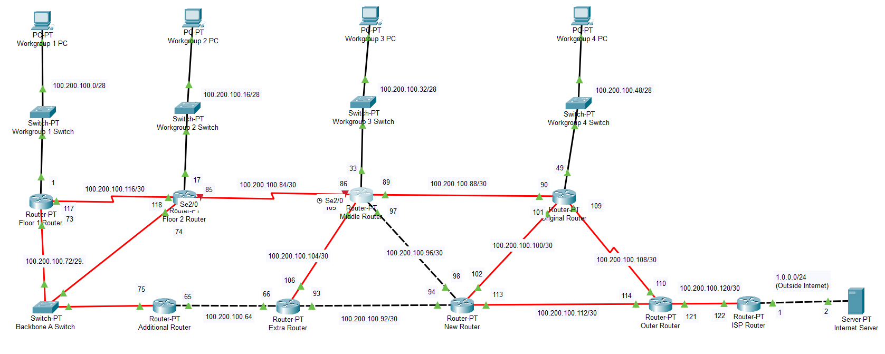

Figure 1: Internetwork testbed with preconfigured VLSM addressing scheme

Task 1: RIPv2

Configuring Routing Information Protocol version 2 (RIPv2) entails enabling the protocol on devices, specifying the version, and defining the networks to participate in the RIP process. RIPv2 employs hop count as its metric and is well-suited for small to medium-sized networks.

The configuration for RIPv2 in Packet Tracer is done via the following commands:
router rip
version 2
network [network_address]
no auto-summary

These commands must be entered in each router, substituting [network_address] with the appropriate address used in each interface of the selected router.
Upon completion, the network configuration table on each router should display all the connected links.

You can test this through ping test and tracert test to do an analysis.

Ping Tests:
Internet Server – Workgroup 1

Workgroup 4 – Additional Router

Tracert Tests:
Internet server – Workgroup 1

Workgroup 4 – Additional Router

Missing/Link down Tests:
Tested the RPv2 to see whether its able to handle a different route when a link goes down. Original Router has been turned off

Internet Server – Workgroup 1
Ping:
Tracert:
Workgroup 4 – Additional Router
New router has been turned off because the device at Workgroup 4 relies on Original Router.

Ping:

Tracert:

Task 2: OSPF

Configuring Open Shortest Path First (OSPF) involves initiating the OSPF process with a unique identifier and specifying network statements with appropriate masks. OSPF employs link-state data to map the network topology and calculates the shortest path using the Dijkstra algorithm, making it ideal for intricate and hierarchical network setups.

Commands for OSPF configuration in Packet Tracer:

router ospf [process_id]
network [network_address] [wildcard_mask] area [area_id]

Testing can be conducted through pings and tracerts across the network to offer a comprehensive analysis.

Ping Test:
Done to test connectivity between the server and client

Internet Server – Workgroup 1
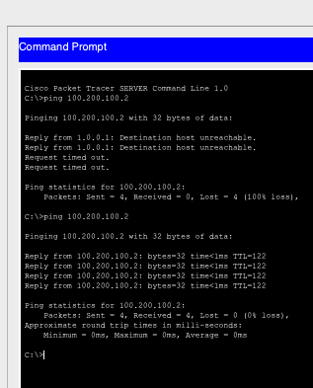

Tracert Tests: Insight into how the server and client are connected
Internet Server – Workgroup1
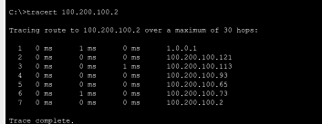

Missing/Link Down Tests: Performed to evaluate the OSPF method's capability in rerouting traffic in the event of a link failure.

Internet Server – Workgroup 1
Ping:
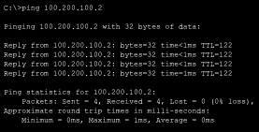
Tracert:
For this test the original router was turned off
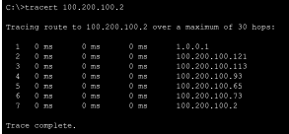
Workgroup 4 – Additional router
New router has been turned off
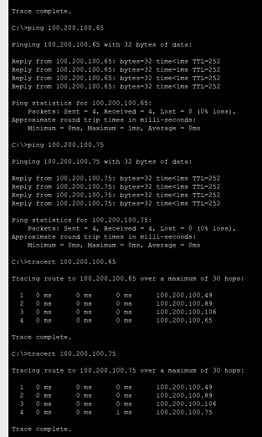

Task 3: EIGRP (Optional)

Setting up Enhanced Interior Gateway Routing Protocol (EIGRP) requires assigning it an autonomous system number and specifying the participating networks using network statements. EIGRP utilizes a composite metric, taking into account factors like delay, bandwidth, reliability, load, and MTU, to select the optimal path and ensures quick network convergence.

I used these commands to configure EIGRP in packet tracer:
router eigrp [AS_number]
network [network_address] [wildcard_mask]

Ping Tests:
Done to test connectivity between client and server.

Internet Server – Workgroup 1
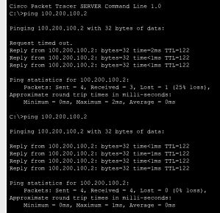
Tracert Tests:
Provide an insight into how the client and server are connected

Internet Server – Workgroup 1

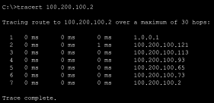

Missing/Link: Conducted to evaluate how the EIGRP method responds by offering an alternate route in the event of a link failure.

Internet Server – Workgroup 1
Original Router has been turned off
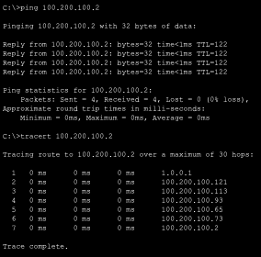
Workgroup 4 – Additional Router
New Router has been turned off.
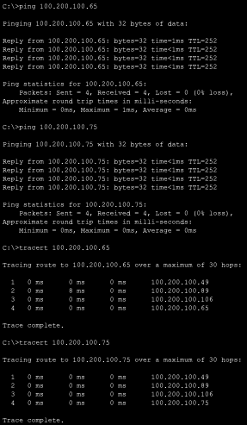
Task 4: Comparison of Protocols

Routing Protocols Comparison
Protocol | Advantages | Drawbacks | Best Suited For
EIGRP | Fast convergence, Efficient bandwidth usage | Proprietary, Complex configuration | Medium to large-sized networks
OSPF | Scalability, Fast convergence, Equal cost load balancing | Resource intensive, Complex configuration | Large, hierarchical networks
RIPv2 | Simplicity, Widely supported, Low overhead | Slow convergence, Hop count limitation | Small to medium-sized networks

Conclusion

Each routing protocol offers unique advantages and drawbacks, catering to different network requirements. EIGRP excels in medium to large-sized networks with its fast convergence and efficient bandwidth usage but may pose challenges due to its proprietary nature and complex configuration. OSPF is ideal for large, hierarchical networks where scalability and fast convergence are paramount, despite its resource-intensive configuration. RIPv2, with its simplicity and wide support, is best suited for small to medium-sized networks, although it suffers from slower convergence and a hop count limitation. Ultimately, the choice of routing protocol depends on factors such as network size, complexity, and administrative capabilities, ensuring optimal network performance and reliability.

Sources:
Cisco. (2023, August 31). Enhanced Interior Gateway Routing Protocol (EIGRP). Retrieved from https://www.cisco.com/c/en/us/support/docs/ip/enhanced-interior-gateway-routing-protocol-eigrp/16406-eigrp-toc.html
Khanna, S. (2009, October 6). RIPV2 (Routing Information Protocol). Retrieved from https://community.cisco.com/t5/networking-knowledge-base/ripv2-routing-information-protocol/ta-p/3117425
IBM. (2023, April 11). Open Shortest Path First (OSPF). Retrieved from https://www.ibm.com/docs/en/i/7.4?topic=routing-open-shortest-path-first

